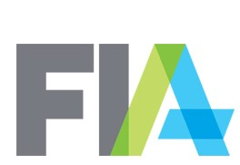

**FIA Standard Agreement Template Review Suggestion Form[1]**

The window for submissions of proposed amendments to the customer and trader versions of the EFP Agreement opens on November 20, 2019 and closes at midnight on December 18, 2019. Please use this form to submit all suggestions and include a blackline of the relevant agreement showing your proposed changes.

***Submissions should be sent to: bthompson@fia.org***

**Submitter’s Information**

Firm Name:

Contact Person:

Phone Number:

Email:

**Suggested Amendment**

Description and purpose of suggested amendment, including any known law or regulation that impacts the suggested language (if applicable) and a link to such law or regulation, and any other support for the suggested amendment:

**Questions from Give-Up Subcommittee**

1. Should a payment flow (for a sourcing broker or other party) be included in this agreement?
2. If so, who is best suited to approve payment flows?

1. This form is intended to seek industry suggestions for use in generating a template agreement. Regardless of whether such suggestions are incorporated in the final template version of the EFP Agreement issued by the FIA Law & Compliance Division, parties are free to amend such agreements to their business needs or preferences.